What is Hardware?
Your PC (Personal Computer) is a system, consisting of many components. Some of those components, like Windows XP, and all your other programs, are software. The stuff you can actually see and touch, and would likely break if you threw it out a fifth-story window, is hardware.
Not everybody has exactly the same hardware. But those of you who have a desktop system, like the example shown in Figure 1, probably have most of the components shown in that same figure. Those of you with notebook computers probably have most of the same components. Only in your case the components are all integrated into a single book-sized portable unit.
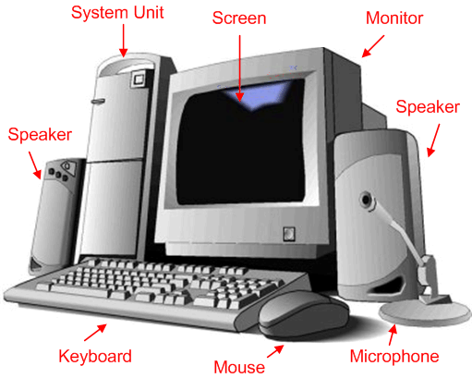
The system unit is the actual computer; everything else is called a peripheral device. Your computer's system unit probably has at least one floppy disk drive, and one CD or DVD drive, into which you can insert floppy disks and CDs. There's another disk drive, called the hard disk inside the system unit, as shown in Figure 2. You can't remove that disk, or even see it. But it's there. And everything that's currently "in your computer" is actually stored on that hard disk. (We know this because there is no place else inside the computer where you can store information!).
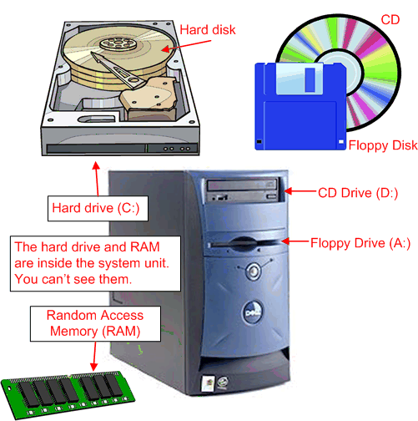
The floppy drive and CD drive are often referred to as drives with removable media orremovable drives for short, because you can remove whatever disk is currently in the drive, and replace it with another. Your computer's hard disk can store as much information as tens of thousands of floppy disks, so don't worry about running out of space on your hard disk any time soon. As a rule, you want to store everything you create or download on your hard disk. Use the floppy disks and CDs to send copies of files through the mail, or to make backup copies of important items.

Random Access Memory (RAM)
There's too much "stuff" on your computer's hard disk to use it all at the same time. During the average session sitting at the computer, you'll probably use only a small amount of all that's available. The stuff you're working with at any given moment is stored in random access memory (often abbreviated RAM, and often called simply "memory"). The advantage using RAM to store whatever you're working on at the moment is that RAM is very fast. Much faster than any disk. For you, "fast" translates to less time waiting and more time being productive.
So if RAM is so fast, why not put everything in it? Why have a hard disk at all? The answer to that lies in the fact that RAM is volatile. As soon as the computer is shut off, whether intentionally or by an accidental power outage, every thing in RAM disappears, just as quickly as a light bulb goes out when the plug is pulled. So you don't want to rely on RAM to hold everything. A disk, on the other hand, holds its information whether the power is on or off.

The Hard Disk
All of the information that's "in your computer", so to speak, is stored on your computer's hard disk. You never see that actual hard disk because it's sealed inside a special housing and needs to stay that way. Unlike RAM, which is volatile, the hard disk can hold information forever -- with or without electricity. Most modern hard disks have tens of billions of bytes of storage space on them. Which, in English, means that you can create, save, and download files for months or years without using up all the storage space it provides.
In the unlikely event that you do manage to fill up your hard disk, Windows will start showing a little message on the screen that reads "You are running low on disk space" well in advance of any problems. In fact, if that message appears, it won't until you're down to about 800 MB of free space. And 800 MB of empty space is equal to about 600 blank floppy disks. That's still plenty of room!

The Mouse
Obviously you know how to use your mouse, since you must have used it to get here. But let's take a look at the facts and buzzwords anyway. Your mouse probably has at least two buttons on it. The button on the left is called the primary mouse button, the button on the right is called the secondary mouse button or just the right mouse button. I'll just refer to them as the left and right mouse buttons. Many mice have a small wheel between the two mouse buttons, as illustrated in Figure 3.
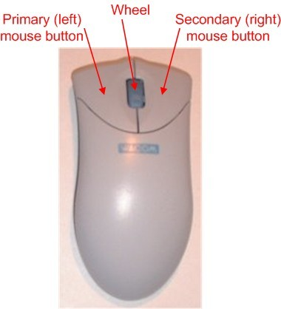
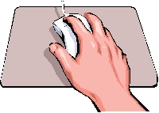
The idea is to rest your hand comfortably on the mouse, with your index finger touching (but not pressing on) the left mouse button. Then, as you move the mouse, the mouse pointer (the little arrow on the screen) moves in the same direction. When moving the mouse, try to keep the buttons aimed toward the monitor -- don't "twist" the mouse as that just makes it all the harder to control the position of the mouse pointer.
If you find yourself reaching too far to get the mouse pointer where you want it to be on the screen, just pick up the mouse, move it to where it's comfortable to hold it, and place it back down on the mousepad or desk. The buzzwords that describe how you use the mouse are as follows:
- Point: To point to an item means to move the mouse pointer so that it's touching the item.
- Click: Point to the item, then tap (press and release) the left mouse button.
- Double-click: Point to the item, and tap the left mouse button twice in rapid succession - click-click as fast as you can.
- Right-click: Point to the item, then tap the mouse button on the right.
- Drag: Point to an item, then hold down the left mouse button as you move the mouse. Todrop the item, release the left mouse button.
- Right-drag: Point to an item, then hold down the right mouse button as you move the mouse. To drop the item, release the right mouse button.

The Keyboard
Like the mouse, the keyboard is a means of interacting with your computer. You really only need to use the keyboard when you're typing text. Most of the keys on the keyboard are laid out like the keys on a typewriter. But there are some special keys like Esc (Escape), Ctrl (Control), and Alt (Alternate). There are also some keys across the top of the keyboard labeled F1, F2, F3, and so forth. Those are called the function keys, and the exact role they play depends on which program you happen to be using at the moment.
Most keyboards also have a numeric keypad with the keys laid out like the keys on a typical adding machine. If you're accustomed to using an adding machine, you might want to use the numeric keypad, rather than the numbers across the top of the keyboard, to type numbers. It doesn't really matter which keys you use. The numeric keypad is just there as a convenience to people who are accustomed to adding machines.
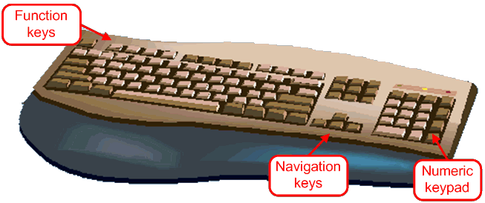
Most keyboards also contain a set of navigation keys. You can use the navigation keys to move around around through text on the screen. The navigation keys won't move the mouse pointer. Only the mouse moves the mouse pointer.
On smaller keyboards where space is limited, such as on a notebook computer, the navigation keys and numeric keypad might be one in the same. There will be a Num Lock key on the keypad. When the Num Lock key is "on", the numeric keypad keys type numbers. When the Num Lock key is "off", the navigation keys come into play. The Num Lock key acts as a toggle. Which is to say, when you tap it, it switches to the opposite state. For example, if Num Lock is on, tapping that key turns it off. If Num Lock is off, tapping that key turns Num Lock on.

Combination Keystrokes (Shortcut keys)
Those mysterious Ctrl and Alt keys are often used in combination with other keys to perform some task. We often refer to these combination keystrokes as shortcut keys, because they provide an alternative to using the mouse to select menu options in programs. Shortcut keys are always expressed as:
key1+key2
where the idea is to hold down key1, tap key2, then release key1. For example, to press Ctrl+Esc hold down the Ctrl key (usually with your pinkie), tap the Esc key, then release the Ctrl key. To press Alt+F you hold down the Alt key, tap the letter F, then release the Alt key.

Personal computer hardware
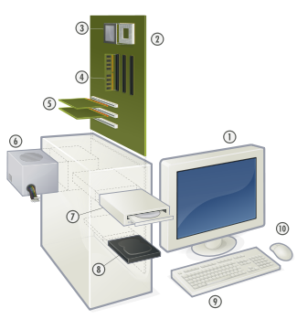
Hardware of a modern Personal Computer.
1. Monitor
2. Motherboard
3. CPU
4. RAM
5. Expansion cards
6. Power supply
7. Optical disc drive
8. Hard disk drive
9. Keyboard
10. Mouse
A personal computer is made up of multiple physical components ofcomputer hardware, upon which can be installed a system software called operating system and a multitude of software applications to perform the operator's desired functions.
Though a PC comes in many different forms, a typical personal computerconsists of a case or chassis in a tower shape (desktop), containing components such as a motherboard.

[edit]Motherboard
Main article: Motherboard
The motherboard is the main component inside the case. It is a large rectangular board with integrated circuitry that connects the rest of the parts of the computer including the CPU, theRAM, the disk drives (CD, DVD, hard disk, or any others) as well as any peripherals connected via the ports or the expansion slots.
Components directly attached to the motherboard include:
- The central processing unit (CPU) performs most of the calculations which enable a computer to function, and is sometimes referred to as the "brain" of the computer. It is usually cooled by a heat sink and fan.
- The chip set mediates communication between the CPU and the other components of the system, including main memory.
- RAM (Random Access Memory) stores resident part of the current running OS (OS core and so on) and all running processes (application parts, using CPU or input/output (I/O) channels or waiting for CPU or I/O channels).
- The BIOS includes boot firmware and power management. The Basic Input Output System tasks are handled by operating system drivers.
- Internal Buses connect the CPU to various internal components and to expansion cards for graphics and sound.
  - Current
    - The north bridge memory controller, for RAM and PCI Express
      - PCI Express, for expansion cards such as graphics and physics processors, and high-end network interfaces
    - PCI, for other expansion cards
    - SATA, for disk drives
    - ATA
  - Obsolete
    - AGP (superseded by PCI Express)
    - VLB VESA Local Bus (superseded by AGP)
    - ISA (expansion card slot format obsolete in PCs, but still used in industrial computers)
- External Bus Controllers support ports for external peripherals. These ports may be controlled directly by the south bridge I/O controller or based on expansion cards attached to the motherboard through the PCI bus.
  - USB
  - FireWire
  - eSATA
  - SCSI

[edit]Power supply
Main article: Power supply unit (computer)
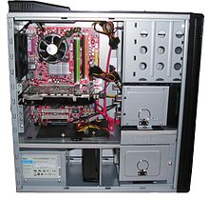
Inside a custom-built computer: the power supply at the bottom has its own cooling fan.
A power supply unit (PSU) converts alternating current (AC) electric power to low-voltage DC power for the internal components of the computer. Some power supplies have a switch to change between 230 V and 115 V. Other models have automatic sensors that switch input voltage automatically, or are able to accept any voltage between those limits. Power supply units used in computers are nearly always switch mode power supplies (SMPS). The SMPS provides regulated direct current power at the several voltages required by the motherboard and accessories such as disk drives and cooling fans.

[edit]Removable media devices
Main article: Computer storage
- CD (compact disc) - the most common type of removable media, suitable for music and data.
  - CD-ROM Drive - a device used for reading data from a CD.
  - CD Writer - a device used for both reading and writing data to and from a CD.
- DVD (digital versatile disc) - a popular type of removable media that is the same dimensions as a CD but stores up to 12 times as much information. It is the most common way of transferring digital video, and is popular for data storage.
  - DVD-ROM Drive - a device used for reading data from a DVD.
  - DVD Writer - a device used for both reading and writing data to and from a DVD.
  - DVD-RAM Drive - a device used for rapid writing and reading of data from a special type of DVD.
- Blu-ray Disc - a high-density optical disc format for data and high-definition video. Can store 70 times as much information as a CD.
  - BD-ROM Drive - a device used for reading data from a Blu-ray disc.
  - BD Writer - a device used for both reading and writing data to and from a Blu-ray disc.
- HD DVD - a discontinued competitor to the Blu-ray format.
- Floppy disk - an outdated storage device consisting of a thin disk of a flexible magnetic storage medium. Used today mainly for loading RAID drivers.
- Iomega Zip drive - an outdated medium-capacity removable disk storage system, first introduced by Iomega in 1994.
- USB flash drive - a flash memory data storage device integrated with a USB interface, typically small, lightweight, removable, and rewritable. Capacities vary, from hundreds of megabytes (in the same ballpark as CDs) to tens of gigabytes (surpassing, at great expense, Blu-ray discs).
- Tape drive - a device that reads and writes data on a magnetic tape, used for long term storage and backups.

[edit]Secondary storage
Hardware that keeps data inside the computer for later use and remains persistent even when the computer has no power.
- Hard disk - for medium-term storage of data.
- Solid-state drive - a device similar to hard disk, but containing no moving parts and stores data in a digital format.
- RAID array controller - a device to manage several internal or external hard disks and optionally some peripherals in order to achieve performance or reliability improvement in what is called a RAID array.

[edit]Sound card
Main article: Sound card
Enables the computer to output sound to audio devices, as well as accept input from amicrophone. Most modern computers have sound cards built-in to the motherboard, though it is common for a user to install a separate sound card as an upgrade. Most sound cards, either built-in or added, have surround sound capabilities.

[edit]Input and output peripherals
Main article: Peripheral
Input and output devices are typically housed externally to the main computer chassis. The following are either standard or very common to many computer systems.
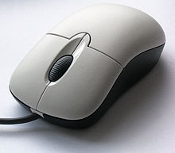

[edit]Input
Main article: Input device
- Text input devices
  - Keyboard - a device to input text and characters by depressing buttons (referred to as keys or buttons).
- Pointing devices
  - Mouse - a pointing device that detects two dimensional motion relative to its supporting surface.
    - Optical Mouse - uses light to determine mouse motion.
  - Trackball - a pointing device consisting of an exposed protruding ball housed in a socket that detects rotation about two axes.
  - Touchscreen - senses the user pressing directly on the display
- Gaming devices
  - Joystick - a control device that consists of a handheld stick that pivots around one end, to detect angles in two or three dimensions and reports its angle or direction to the device it is controlling.
  - Game pad - a hand held game controller that relies on the digits (especially thumbs) to provide input.
  - Game controller - a specific type of controller specialized for certain gaming purposes.
- Image, Video input devices
  - Image scanner - a device that provides input by analyzing images, printed text, handwriting, or an object.
  - Web cam - a video camera used to provide visual input that can be easily transferred over the internet.
- Audio input devices
  - Microphone - an acoustic sensor that provides input by converting sound into electrical signals.

[edit]Output
Main article: Output device
- Printer - a device that produces a permanent human-readable text of graphic document.
- Speakers - typically a pair of devices (2 channels) which convert electrical signals into audio.
  - Headphones - for a single user hearing the audio.
- Monitor - an electronic visual display with textual and graphical information from the computer.
  - CRT - (Cathode Ray Tube) display
  - LCD - (Liquid Crystal Display) as of 2010, it is the primary visual display for personal computers.
  - LED - (light-emitting diode) display
  - OLED - Organic Light-Emitting Diode

[edit]See also
- Glossary of computers
[hide]v · d · eBasic computer components
Input devices | Keyboard · Pointing device (Joystick · Light pen · Mouse · Touchpad ·Touchscreen · Trackball) · Microphone · Scanner · Webcam
Output devices | Monitor · Speakers · Printer
Removable data storage | Floppy disk · Compact Disc ReWritable / DVD Drive · USB flash drive ·Memory card
Computer case | Central processing unit · RAM · Video card · Sound card · Motherboard ·Power supply · Hard drive · Network interface controller
Data ports | Ethernet · Firewire (IEEE 1394) · Parallel port · Serial port · Universal Serial Bus(USB)

Categories: Personal computers | Computer hardware | Personal computing

